UML Use Case Diagram
Maestro Enterprise Sovereign RAG

System Use-Case Scope
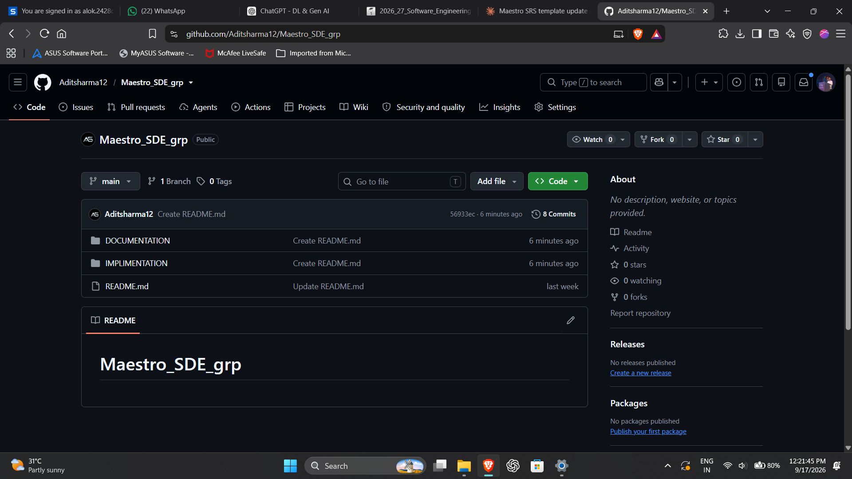
The primary actor is the Authenticated User. Supporting actors are Clerk, Groq, PostgreSQL, Amazon Neptune and Qdrant. The diagram emphasizes user-visible capabilities while showing the external services that participate in those use cases.

PlantUML Source
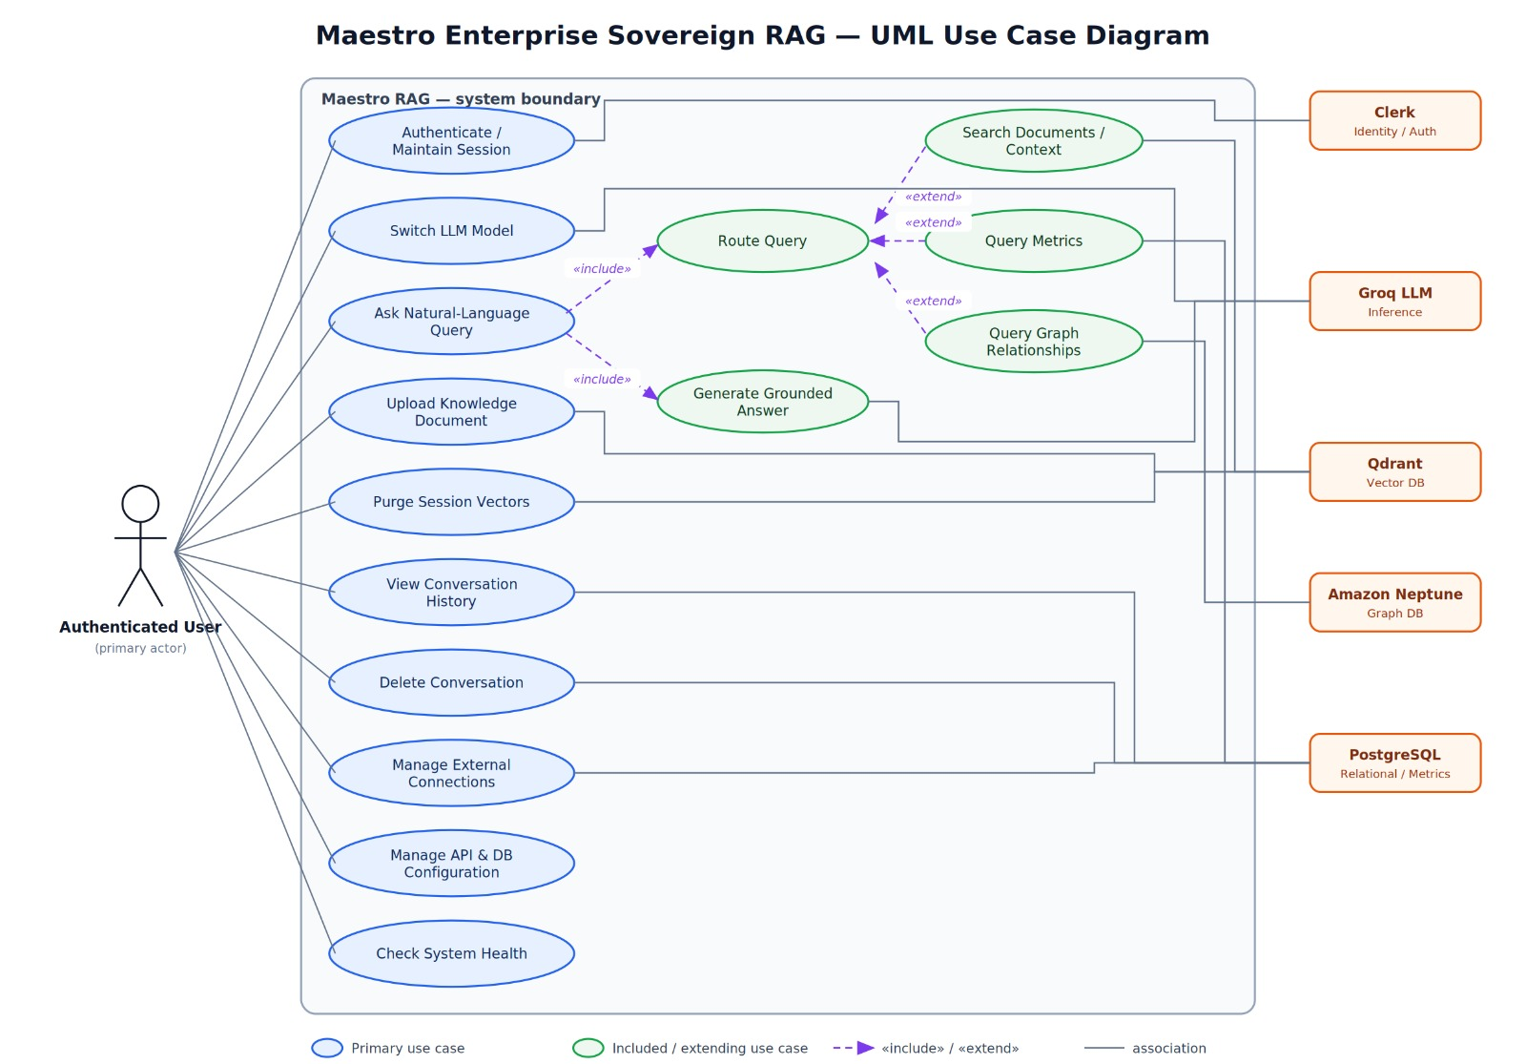

Use-Case Notes
- Ask Natural-Language Query includes intent routing and grounded answer generation.
- Qdrant is the primary source for documentation/context, PostgreSQL for quantitative metrics, and Neptune for graph relationships.
- Upload Knowledge Document creates vector representations for later semantic search.
- Purge Session Vectors supports the Safe-RAG lifecycle.
- Configuration and connection management cover credential setup and registration of named external data targets.

